Technical Architecture – Job Inclusivity Tool (As-Is | AWS Native)

1. Document Control
Attribute | Value
Application Name | Job Inclusivity Tool
Architecture State | As-Is (Current State)
System Type | External AI/ML Service
Primary Platform | AWS
Consuming System | Workday Recruiting
Hosting Model | Cloud – AWS
Geography | English-speaking countries
Data Classification | Internal
Version | 1.0
Status | Approved
Last Updated | DD-MMM-YYYY

2. Purpose of This Document
This document describes the current (As-Is) technical architecture of the Job Inclusivity Tool, an AWS-hosted AI/ML solution integrated with Workday Recruiting to evaluate and improve job description inclusivity during the job requisition lifecycle.
This architecture reflects:
- The existing AWS-native implementation
- Current ML scoring logic
- Existing integration touchpoints with Workday
- Operational and security considerations

3. Business Context
Problem Statement
Despite being qualified, candidates from vulnerable populations often self-select out of roles due to:
- Unclear job descriptions
- Biased or exclusionary language
- Lack of transparency in job postings
Business Objectives
- Improve accessibility of job postings
- Reduce biased self-de-selection
- Provide measurable inclusivity metrics before job posting

4. Scope
In Scope
- Job requisition evaluation
- Job description inclusivity scoring
- Recommendation generation
- Score recalculation after updates
- Storage of scoring results
Out of Scope
- Candidate screening
- Interview evaluation
- Hiring decisions
- Offer management

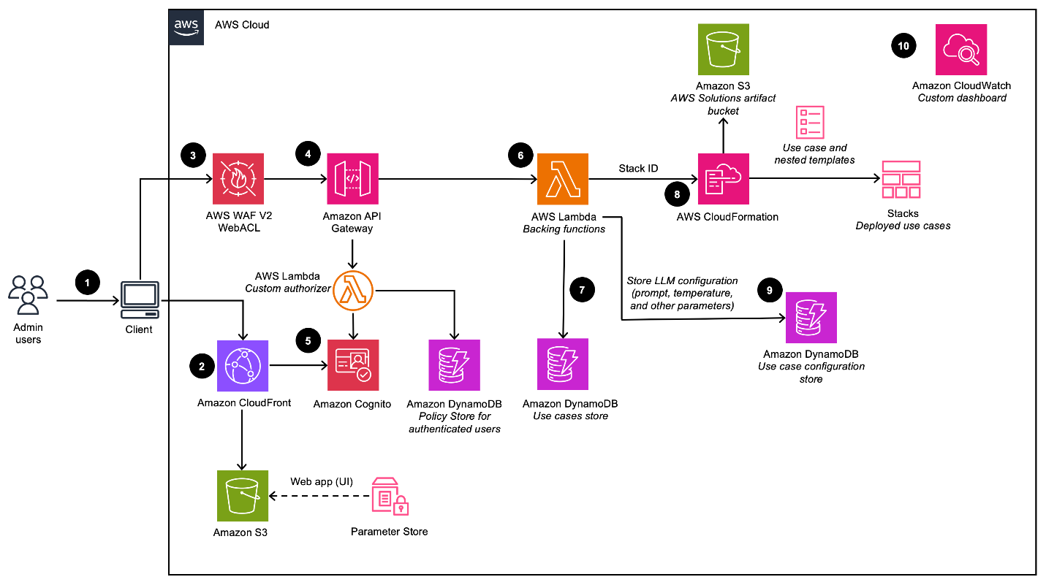
Architecture Pattern:
External AI/ML Scoring Service invoked by Workday during Job Requisition lifecycle
Key Characteristics
- Workday remains System of Record
- Inclusivity logic fully hosted in AWS
- Stateless scoring with persistent audit storage
- Human-in-the-loop decision making
6. Logical Architecture (As-Is)

┌────────────────────────────────────┐
│ Workday Recruiting │
│ Job Requisition Creation │
└───────────────┬────────────────────┘
│ API Invocation
┌───────────────▼────────────────────┐
│ AWS API Gateway │
│ Secure REST Endpoint │
└───────────────┬────────────────────┘
│
┌───────────────▼────────────────────┐
│ AWS Compute Layer │
│ (Lambda / Container / EC2) │
│ Scoring Orchestration │
└───────────────┬────────────────────┘
│
┌───────────────▼────────────────────┐
│ ML / GenAI Engine │
│ Inclusivity Scoring Logic │
└───────────────┬────────────────────┘
│
┌───────────────▼────────────────────┐
│ Data Store │
│ Scores, Features, History │

7. Component Architecture (As-Is)
7.1 Workday Recruiting
- Job requisition creation and updates
- Job description authoring
- Triggers inclusivity evaluation
- Displays score and recommendations (embedded UI / iframe / redirect)
Workday does not perform scoring — it consumes results.

7.2 AWS API Layer
- AWS API Gateway
- Exposes REST endpoints for:
  - Initial score calculation
  - Score recalculation
- Authenticated via secure tokens

7.3 AWS Compute Layer
- Executes scoring workflows
- Handles:
  - Request validation
  - Feature extraction
  - Model invocation
- Scales automatically with hiring volume

7.4 ML Engine
Responsibilities
- Analyze job description text
- Apply trained ML models
- Generate:
  - Overall Inclusivity Score
  - Category-level scores
  - Recommendations
Model Inputs
- Job title
- Job description text
- Location / region metadata

7.5 Data Persistence Layer
Stores:
- Inclusivity scores
- Feature-level results
- Historical score changes
- Recommendation acceptance status
Used for:
- Audit
- Trend analysis
- Model improvement

8. Inclusivity Scoring Model (As-Is)
Categories (4)
Category | Purpose
Clarity of Posting | Helps candidates assess role fit
Inclusive Culture | Signals organizational inclusivity
Exclusive Practices | Identifies deterrent requirements
Language | Detects biased or exclusive terminology
Feature Coverage
- 22 features contribute to the final score
- Each feature produces a binary or weighted signal
- Aggregated into a composite score
9. End to End Process (As-Is)
Flow Description
- Manager creates job requisition in Workday
- Requisition flagged for inclusivity review
- Job description sent to AWS scoring service
- Inclusivity score calculated
- Score and recommendations returned
- Recruiter reviews recommendations
- JD updated (optional)
- Score recalculated
- Requisition submitted
- Job posted
- 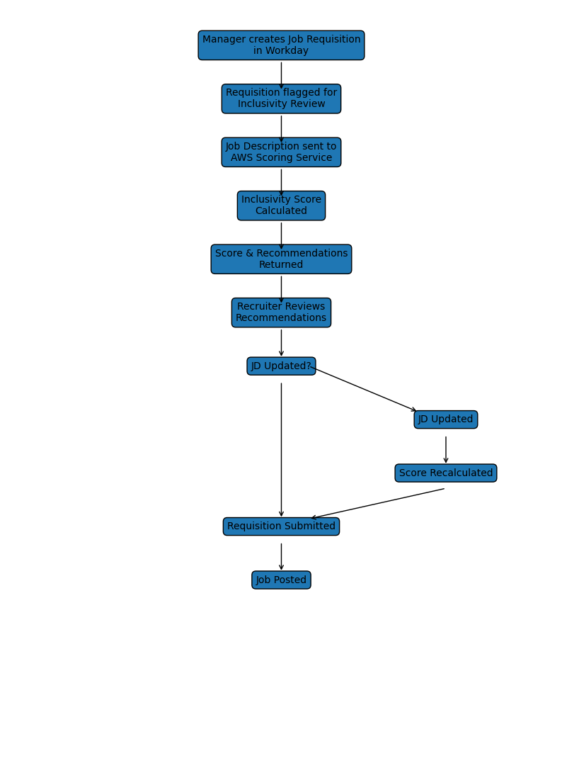

10. Security Architecture
Authentication
- API token-based authentication
- HTTPS/TLS encryption
Authorization
- Workday role-based access
- AWS IAM role separation
Data Protection
- No candidate PII processed
- JD text treated as internal data
- Encrypted at rest and in transit

- Non-Functional Characteristics
Area | As-Is Design
Availability | ≥ 99.9%
Performance | < 3 seconds scoring
Scalability | Auto-scale during hiring peaks
Resilience | Stateless compute
Localization | English only

12. Operations & Support Model
Ownership
Component | Owner
Workday Integration | HR Technology
AWS Platform | Cloud / Platform Team
ML Models | Data Science Team
Monitoring | DevOps
Monitoring
- API failures
- Latency spikes
- Model anomalies

13. Risks & Mitigations (As-Is)
Risk | Impact | Mitigation
Model bias | Inaccurate scoring | Regular retraining
API outage | Process delay | Retry & fallback
Over-editing JD | Loss of intent | Recruiter review

14. Assumptions & Constraints
Assumptions
- Workday is the system of record
- Recruiters manually accept recommendations
Constraints
- Job board character limits
- English language only
- External system dependency

15. Future Considerations (Out of Scope)
- Workday-native implementation
- Multi-language support
- Analytics dashboards
- Candidate outcome correlation
16. Change Log
Version | Date | Description | Owner
1.0 | 21-Jun-2023 | As-Is Architecture Baseline | EA Team

